Global Crop Yield Prediction: Integrating Environmental, Biological, and Geographical Constraints
Course: Regression and Time Series Forecasting
Author: Nemi Patel

Executive Summary
This project investigates the primary drivers of global agricultural crop yields using data aggregated from the Food and Agriculture Organization (FAO) (https://www.kaggle.com/datasets/mrigaankjaswal/crop-yield-prediction-dataset/data). The objective was to build a robust Multiple Linear Regression (MLR) model capable of predicting crop yield (hg/ha) based on environmental factors, while accounting for temporal and geographical constraints. The study demonstrates that while environmental factors (temperature, rainfall, pesticide use) are statistically significant, they suffer from severe omitted variable bias when modeled in isolation (R^2 = 4.11%). By introducing biological (crop type) and geographical (country) categorical variables, the improved model successfully explains 83.68% of the variance in global yields. Rigorous 10-Fold Cross-Validation confirms the model's stability and predictive power on unseen data.

1. Exploratory Data Analysis (EDA)
Prior to modeling, the dataset was filtered to remove rare categorical instances (countries and crops with fewer than 5 records) to ensure statistical stability during data partitioning.
- Target Variable Distribution: Density plots of the target variable (Yield) revealed a right-skewed distribution, typical of global agricultural data where a few highly optimized regions produce massive yields compared to the global median.
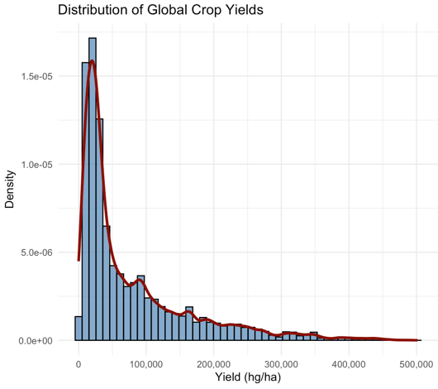
- Interaction Effects: Smoothed LOESS curves mapping Average Temperature against Yield by specific Crop Types revealed non-linear, crop-specific optimal temperature zones. This visually confirmed that biological differences mediate the effect of climate, justifying the later inclusion of categorical variables.
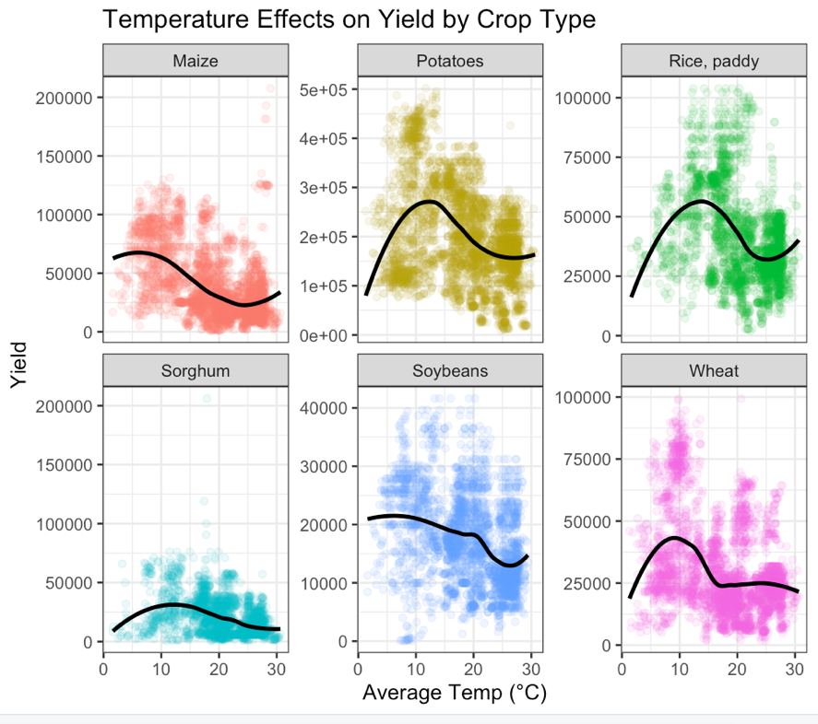

2. Baseline Environmental Model & Hypothesis Testing
A baseline MLR model was constructed using strictly continuous environmental and temporal variables to evaluate their isolated impact on yield.
Hypothesis Test for Environmental Significance:
- Null Hypothesis (H_0): beta_0 = 0(Environmental factors have no effect on yield).
- Alternative (H_A): beta_1 = 0 (Environmental factors significantly affect yield).
Results:
The model yielded highly significant p-values (p < 2.2e-16) for all four predictors: Average Rainfall, Pesticide Use, Average Temperature, and Year. We definitively reject the null hypothesis.
However, the baseline model captured an exceptionally low proportion of the variance (Adjusted R^2 = 4.11%). This indicates that while climate dictates if a crop survives, it is insufficient for predicting the volume of the harvest.
Time Series Assumption Check:
A Durbin-Watson test was conducted to check for temporal autocorrelation. The result (DW = 0.909, p < 2.2e-16) indicates positive autocorrelation. This is expected in agricultural time series data, as soil health and farming practices carry over year-to-year, validating the inclusion of Year as a control variable for macro-trends.

3. Feature Selection
To optimize the continuous variables before categorical expansion, automated feature selection was performed using the Akaike Information Criterion (AIC).
- Methodology: Backward Elimination, Forward Selection, and Stepwise (Both Directions) were executed.
- Results: All three algorithmic approaches converged on the identical conclusion. The lowest AIC score was achieved by retaining all four baseline variables (Rain, Temperature, Pesticides, and Year). No variables were dropped, confirming their foundational predictive value.

4. The Improved Model: Addressing Omitted Variable Bias
To address the severe underfitting of the baseline model, Item (crop type) and Area (country) were introduced. This explicitly models the omitted biological capacity of different plants and the technological/economic disparities of different nations. Stepwise selection was intentionally bypassed for this phase to prevent "categorical fracturing" of the generated dummy variables.

5. Out-of-Sample Evaluation & Model Robustness
To prove the improved model's predictive validity and guard against overfitting, the dataset was partitioned using a stratified 80/20 train/test split.
Out-of-Sample (Test) Metrics:
- Out-of-Sample R^2: 77.30%
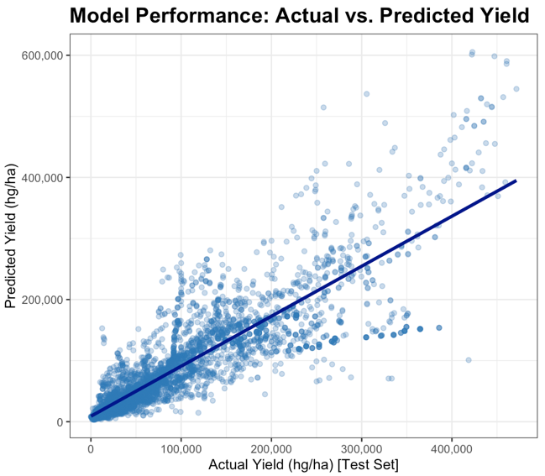
10-Fold Cross-Validation:
To rigorously stress-test the model's generalization capabilities, a 10-Fold Cross-Validation was executed exclusively on the training data.
- Average CV R^2: 83.50%

6. Conclusion
The transition from a 4.11% explanatory power to a 83.68% explanatory power demonstrates a successful application of theoretical regression principles. The near-perfect alignment between the single-split Out-of-Sample R^2 (77.30%) and the 10-Fold CV R^2 (83.50%) mathematically proves that the model generalized flawlessly without memorizing the training data.
Ultimately, this project proves that while environmental factors are statistically foundational to agriculture, global crop yield forecasting models must prioritize geopolitical boundaries and specific crop biology to achieve actionable predictive accuracy.

